Assignment 1: Create an IAM user with username of your own wish and grant administrator policy.

Ans.

Created a user called ‘Spiderman’.

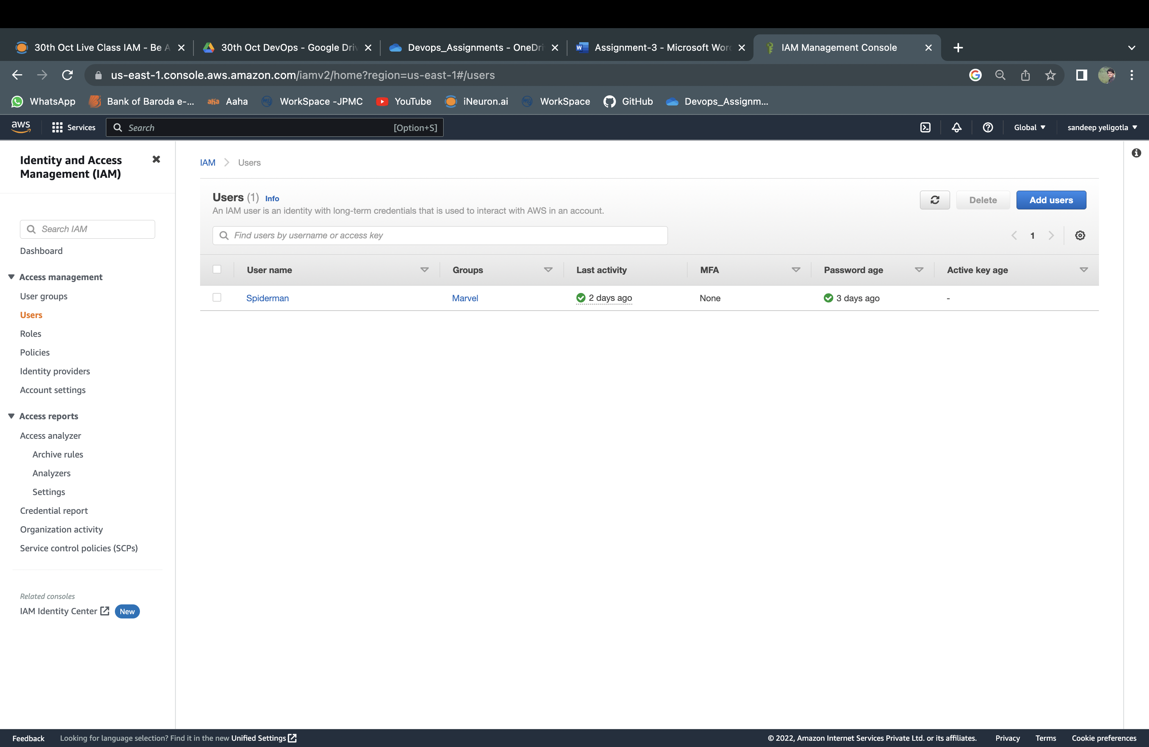

Granted Administrator policy to the above user.

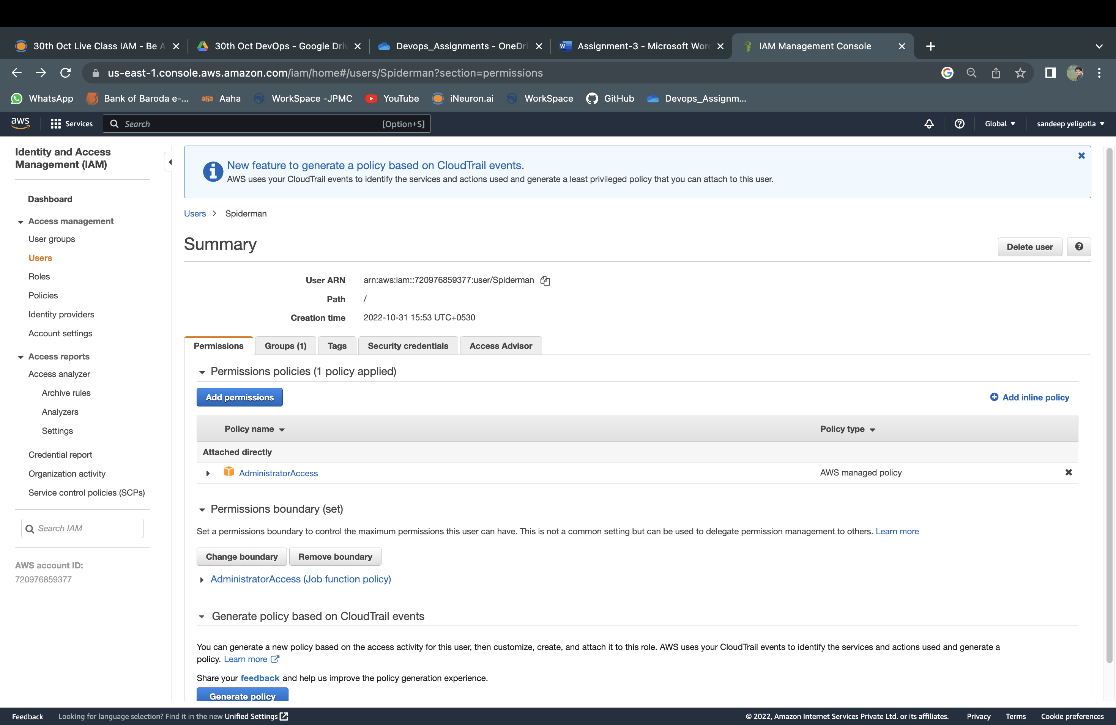

Assignment 2: Hello students, in this assignment you need to prepare a developer's team of avengers. Create 3 IAM users of avengers and assign them to developer’s groups with IAM policy.

Ans.

Created 3 users assigned them to a group called Avengers and assigned IAM full access policy to the group.

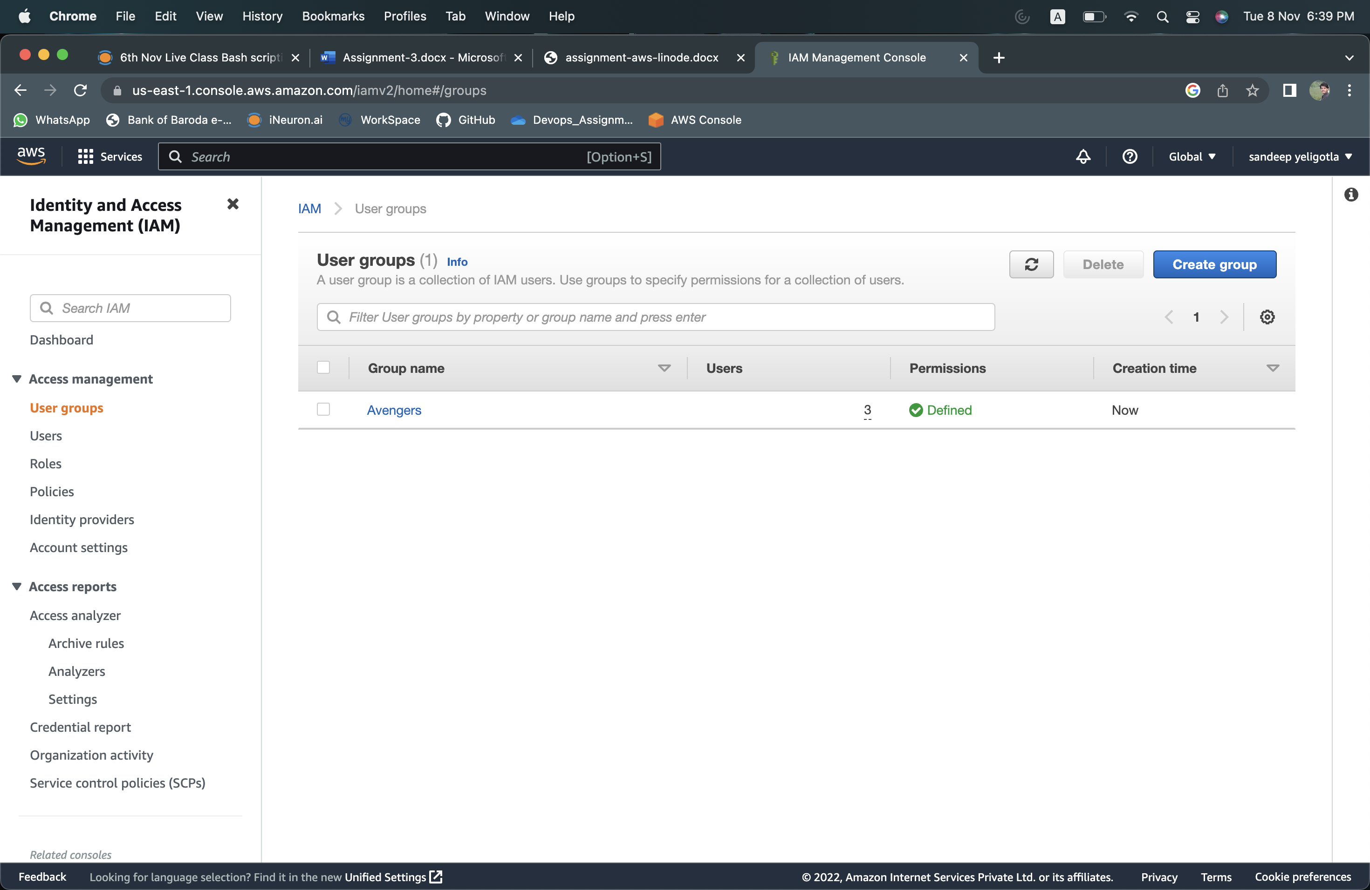

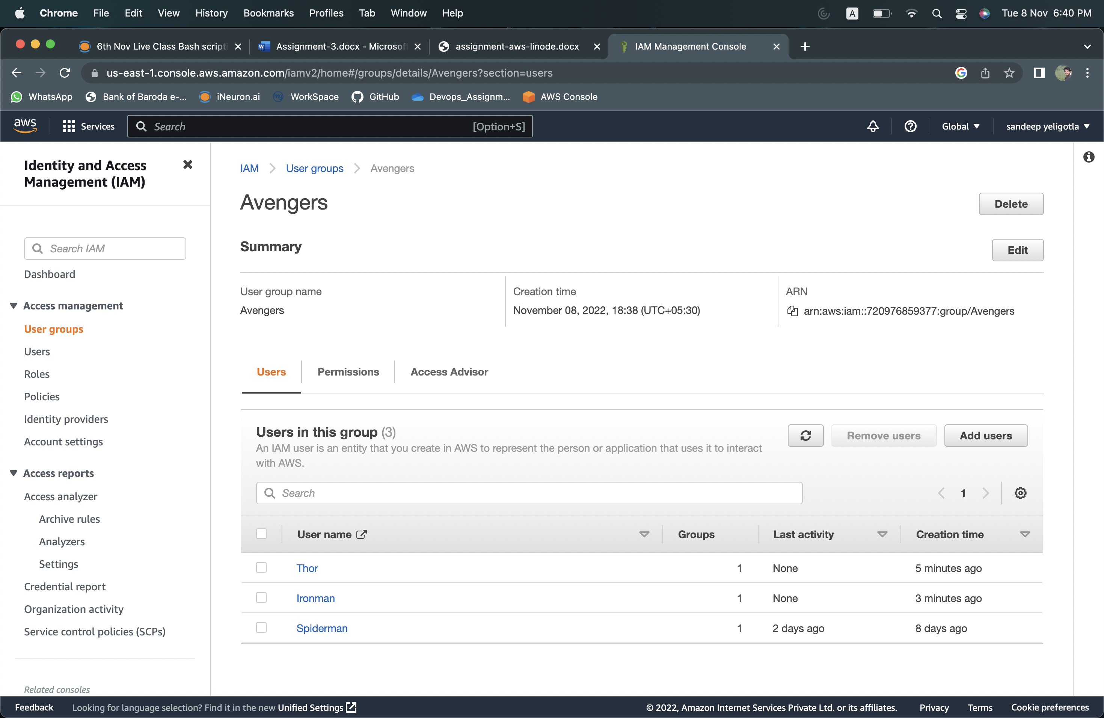

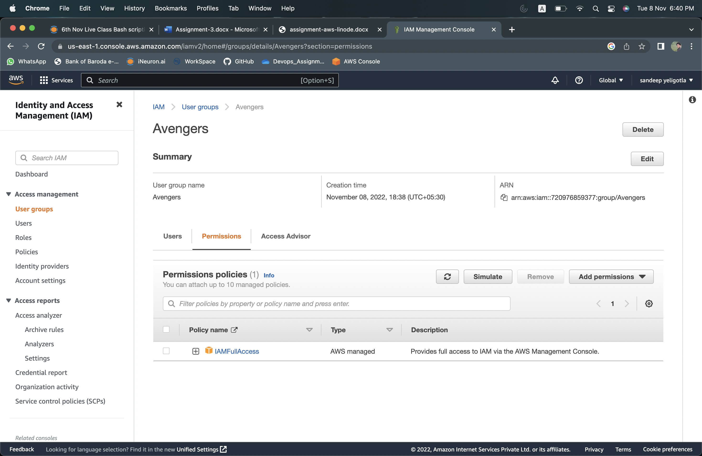

Assignment 3: Define a condition in policy for expiration like

"DateGreaterThan": {"aws:CurrentTime": "2020-04-01T00:00:00Z"},

"DateLessThan": {"aws:CurrentTime": "2020-06-30T23:59:59Z"}

Define the span of 4 months as per your wish.

Ans.

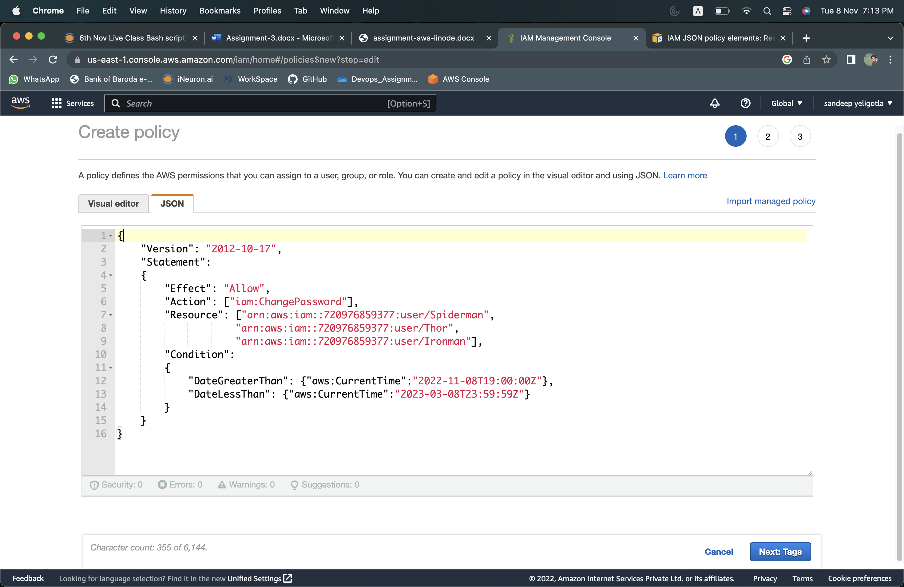

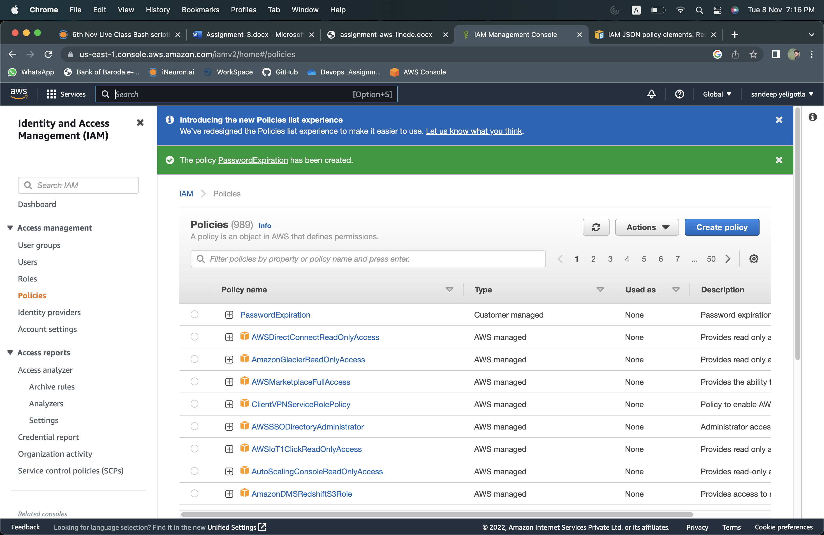

Assignment 4: Prepare 15 authentic MCQ questions related to IAM.

1. What do you mean by IAM user?

|  |  |
| --- | --- |
| (a) | Entity that you create in AWS |
| (b) | It gives people the ability to sign in to the AWS Management Console for interactive tasks and to make programmatic requests to AWS services using the API or CLI |
| (c) | A and B both |
| (d) | None of these |

1. Identify the wrong statement related to IAM?

|  |  |
| --- | --- |
| (a) | Identity and access management (IAM) is a framework for business processes that facilitates the management of electronic or digital identities |
| (b) | With IAM technologies, IT managers can control user access to critical information within their organizations |
| (c) | Identity and access management products offer role-based access control |
| (d) | In IAM roles are defined according to the ability of an individual user to perform a specific task, such as view, create or modify a file |

1. **What does AWS evaluate when an IAM principal makes a request?**

|  |  |
| --- | --- |
| (a) | Username and Password |
| (b) | MAC Address |
| (c) | Security Policies |
| (d) | IP Address |

1. **Which of these is not an IAM policy type?**

|  |  |
| --- | --- |
| (a) | Smart policies |
| (b) | Access control lists (ACLs) |
| (c) | Session policies |
| (d) | Organizations SCPs |

1. **Names of IAM identities (users, roles, and groups)** must be unique within**?**

|  |  |
| --- | --- |
| (a) | AWS account |
| (b) | Availability zone |
| (c) | Region |
| (d) | AWS cloud whole |

1. **How many maximum groups can be created in an AWS account?**

|  |  |
| --- | --- |
| (a) | 25 |
| (b) | 50 |
| (c) | 100 |
| (d) | 200 |

1. **How many maximum users can be created in an AWS account?**

|  |  |
| --- | --- |
| (a) | 2000 |
| (b) | 5000 |
| (c) | 8000 |
| (d) | 10000 |

1. **How many maximum access keys can be assigned to an IAM user?**

|  |  |
| --- | --- |
| (a) | 1 |
| (b) | 2 |
| (c) | 3 |
| (d) | 4 |

1. **How many maximum customer-managed policies can be created in an AWS account?**

|  |  |
| --- | --- |
| (a) | 250 |
| (b) | 500 |
| (c) | 750 |
| (d) | 1000 |

1. **IAM role:**

|  |  |
| --- | --- |
| (a) | Have credentials (password or access keys) associated with it |
| (b) | Does not have any credentials (password or access keys) associated with it |
| (c) | May or may not have credentials (password or access keys) associated with it |
| (d) | None of these |

1. **IAM group:**

|  |  |
| --- | --- |
| (a) | Is same as IAM users |
| (b) | Can be used to specify permissions for a collection of users |
| (c) | Is truly an identity |
| (d) | All of these |

1. **Which of these is Identity in IAM?**

|  |  |
| --- | --- |
| (a) | Users |
| (b) | Groups |
| (c) | Roles |
| (d) | All of these |

1. **When you first create an Amazon Web Services (AWS) account, you begin with a single sign-in identity that has complete access to all AWS services and resources in the account. This identity is called?**

|  |  |
| --- | --- |
| (a) | Root user |
| (b) | Main user |
| (c) | Super user |
| (d) | None of these |

1. Which user has no permission by default?

|  |  |
| --- | --- |
| (a) | EC2 |
| (b) | IAM |
| (c) | Root |
| (d) | Service |

1. IAM policy documents are written in which format?

|  |  |
| --- | --- |
| (a) | XML |
| (b) | HTML |
| (c) | JSON |
| (d) | YAML |

1. One of the elements is an optional element of an IAM policy document, which one is it?

|  |  |
| --- | --- |
| (a) | Action |
| (b) | Version |
| (c) | Effect |
| (d) | Condition |

1. Which of these are features of IAM?

|  |  |
| --- | --- |
| (a) | **Password Policy** |
| (b) | **Access Advisor** |
| (c) | Billing Report |
| (d) | dentity Provider |

Assignment 5: Launch your linux instance in IAM and update your machine.

Ans.

Logged into IAM user Spiderman.

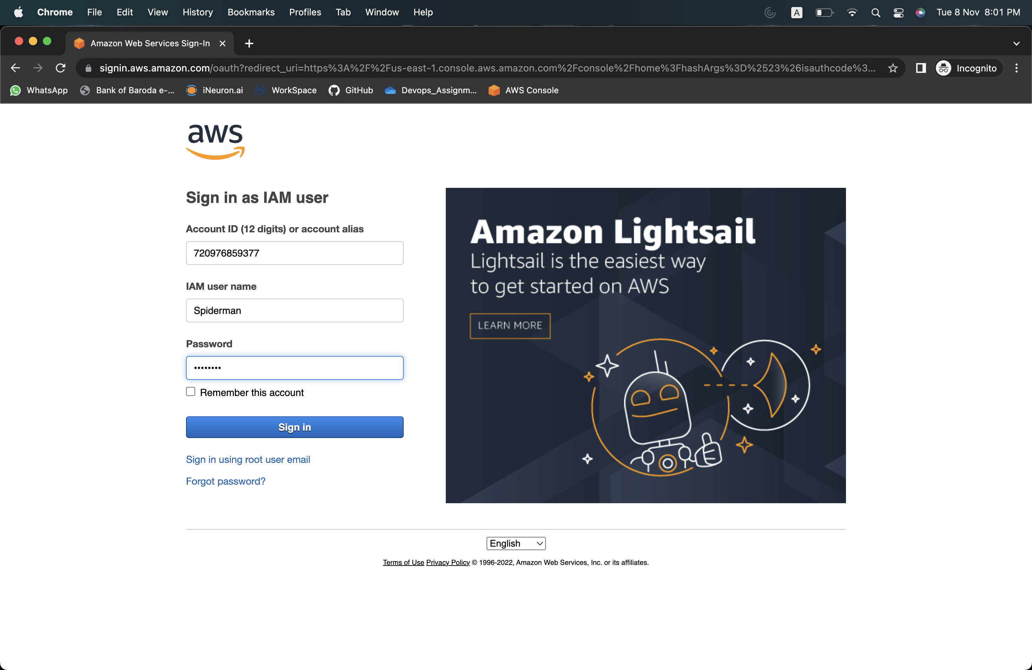

Launching the created instance.

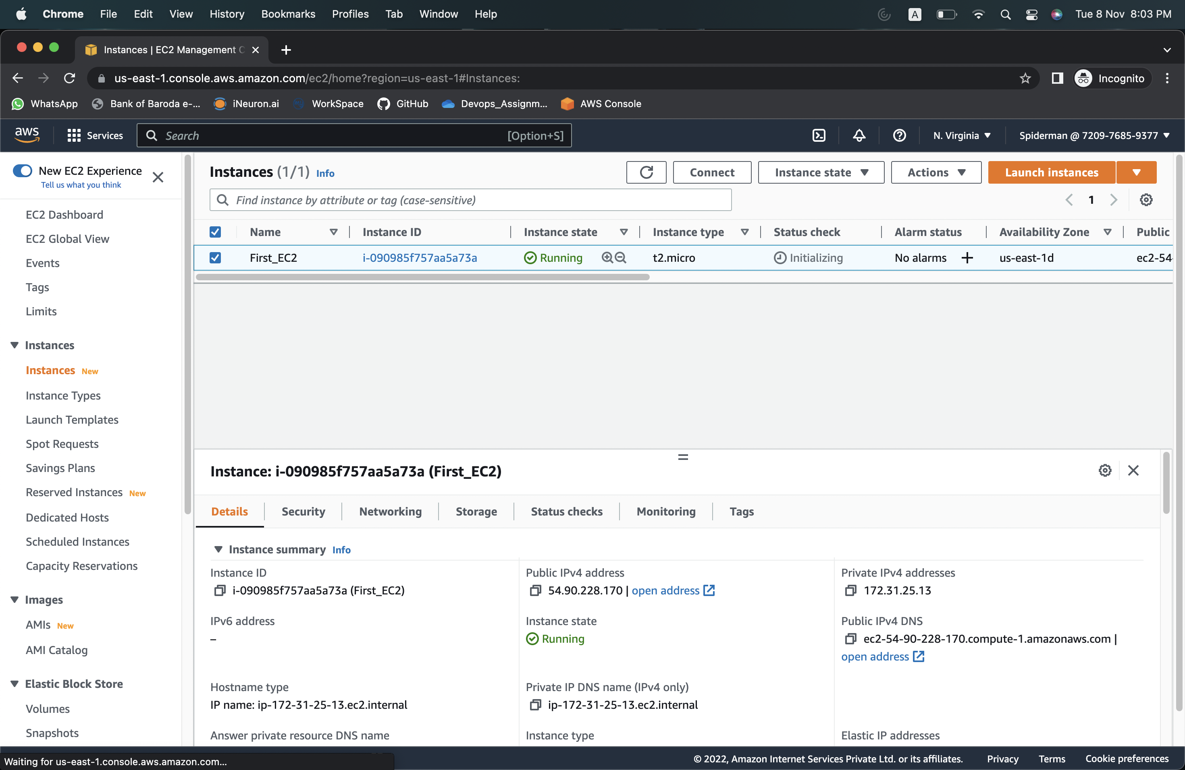

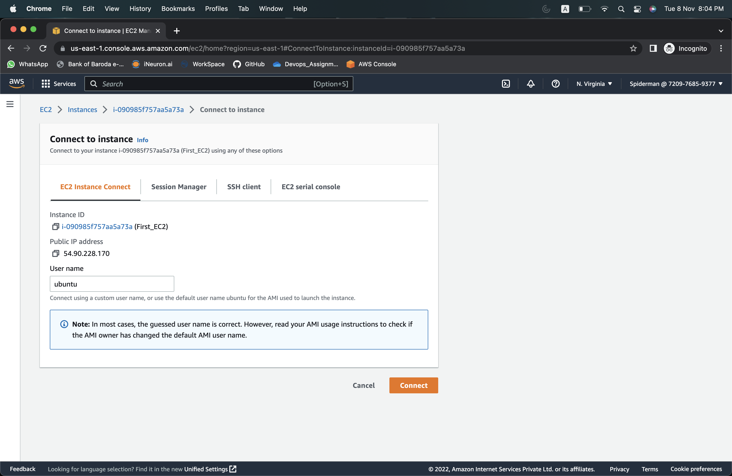

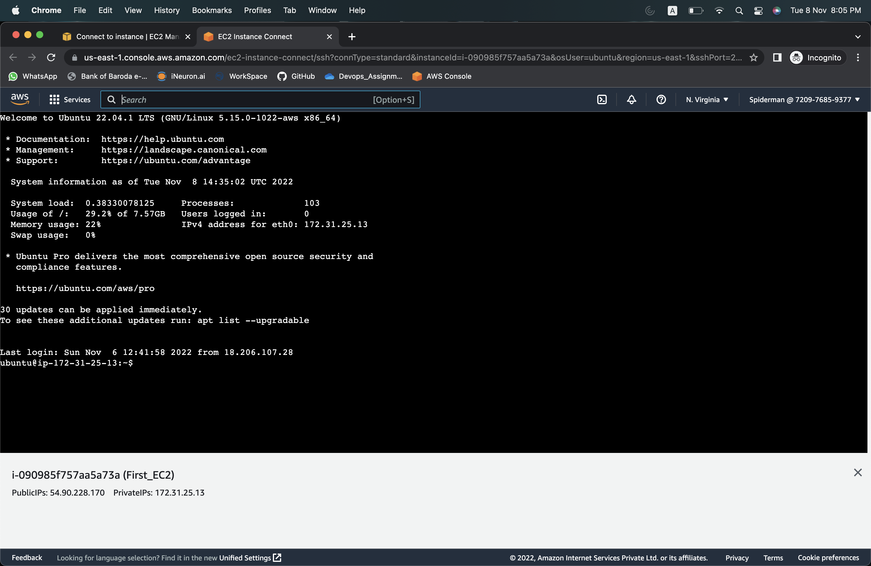

Updated the machine by using the command “apt-get update”

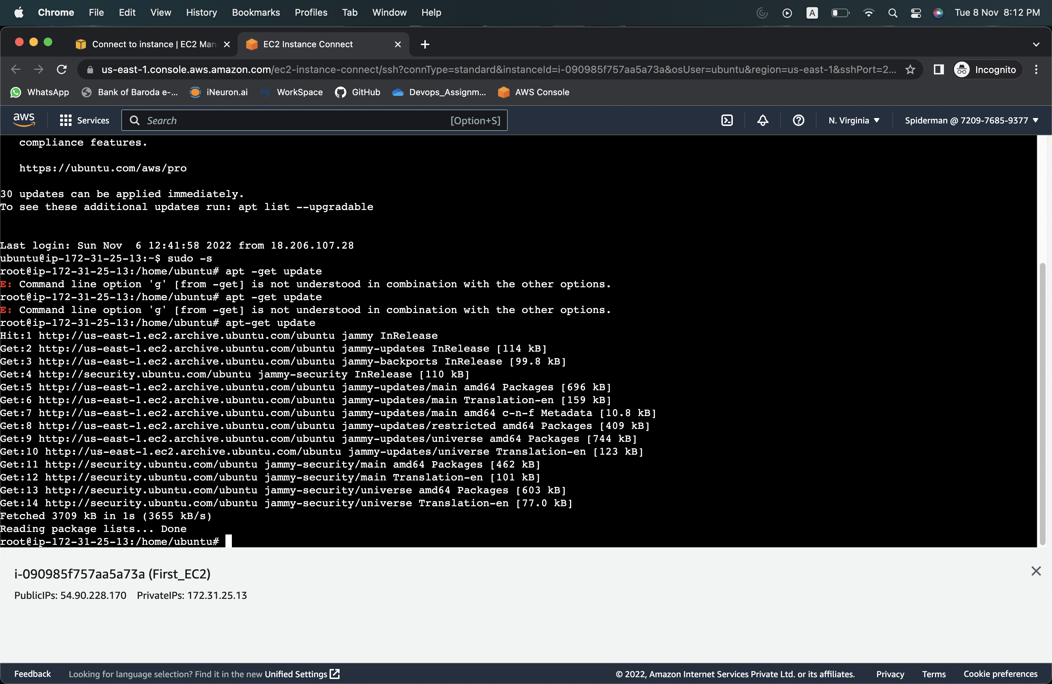

Updated the disk using the command “apt-get dist-upgrade"

